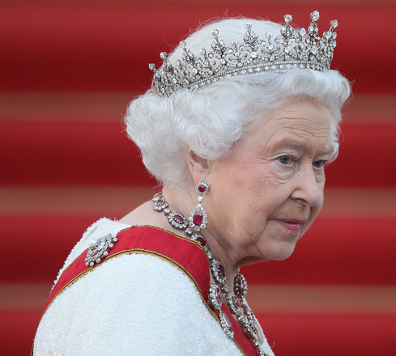
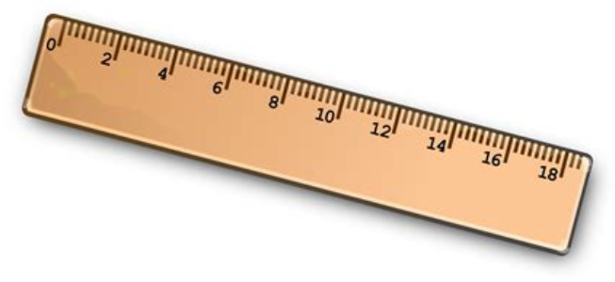
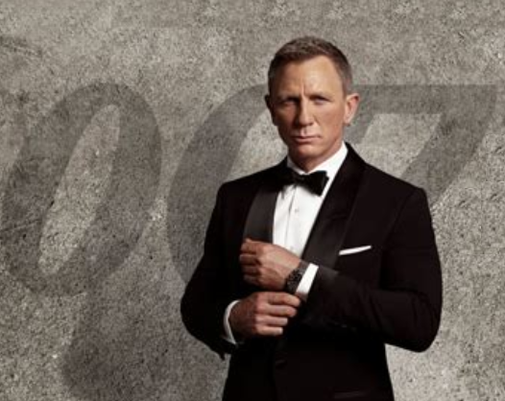
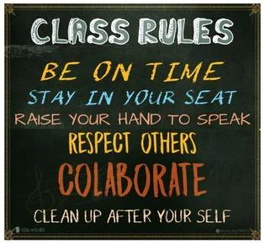
English Vocabulary: “rule” vs “role”

RULE

1. The period of administration of a country or territory.

Queen Elizabeth II was the ruler of the UK for 70 years.
Her rule was the longest in history.

2. A guide for conduct or action.

3. Measurement.

We use a “rule” or “ruler” to measure short distances.

ROLE

1. A part played by an actor in a film or play.

Daniel Craig currently plays the role of James Bond.

2. A specific function in a process.

Each government plays an important role in the combat
against global warming.

(to play a role – fazer papel / ter papel)

